pfSense installation guide for my project

pfSense is software-based distribution for a free network firewall, pfSense based on the free BSD OS with a customized kernel and additional third-party free software packages. With the assistance of the package system, pfSense software can deliver the same functionality, or more, than common commercial firewalls without any of the artificial limitations. You won't believe that it has actually taken over all big-name commercial firewall you can count on the hand in very many installations worldwide such as Check Point, Cisco PIX, Cisco ASA, Juniper, Sonicwall, Netgear, Watchguard, Astaro, and more.

After downloading and Installation of pfSense firewall, we first start configuring WAN and LAN by adding Network adapters to Virtual Machine through Vmware. For the next step we go inside pfsense first assign interfaces for linking to VM NAT of Virtual machines. By finishing this step, we go to set interface IP address and setting web configuration IP address for configuration through Web Browsers.

After that we go to the web configuration page register and rename Interfaces. Then adding rules to every Virtual machine rule which we need.

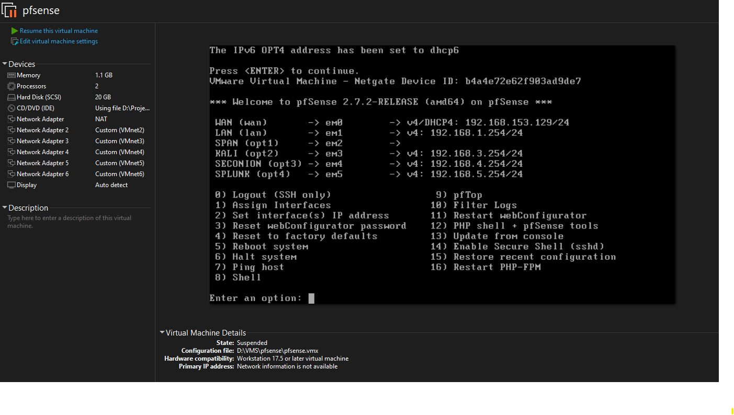

This screenshot is from pfSense CLI after assigning all interfaces through CLI and renaming it from web configuration through Windows 10 end-user.

*The pfSense web configuration page after editing data for registration. And configuring IP routes.*

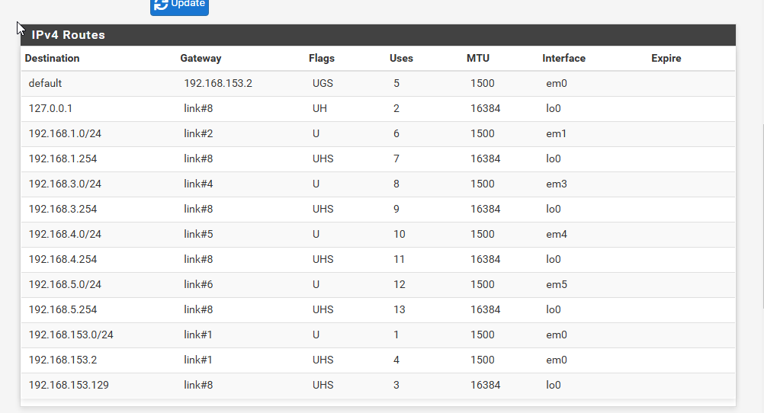

*IPV4 Routes in firewall configuration.*

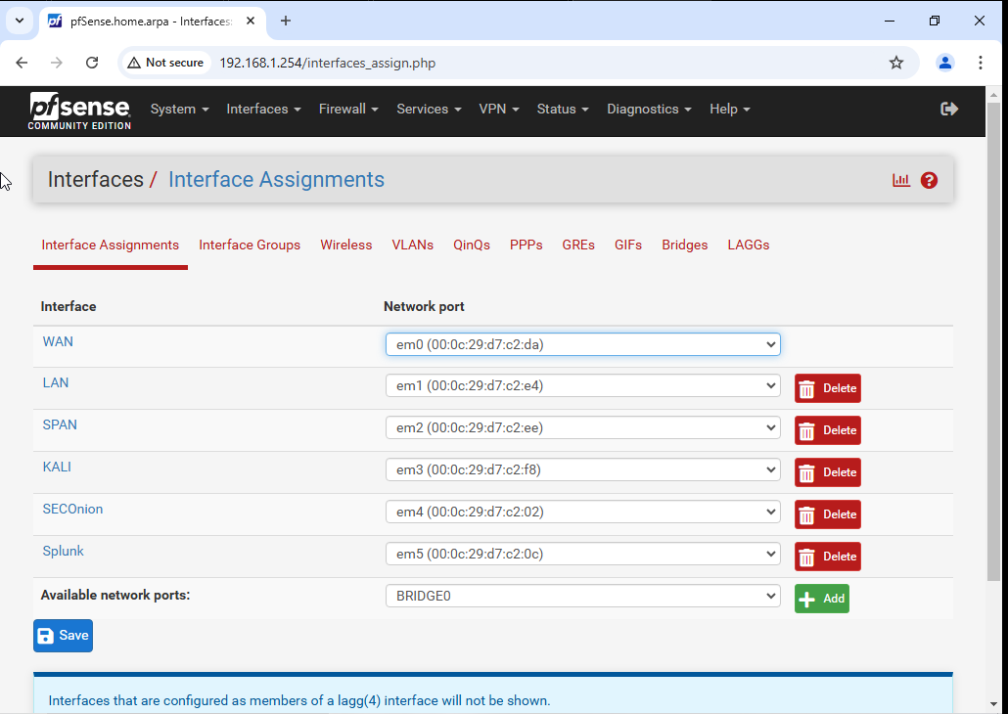

*Assigned Interfaces on web configuration page of pfSense*

*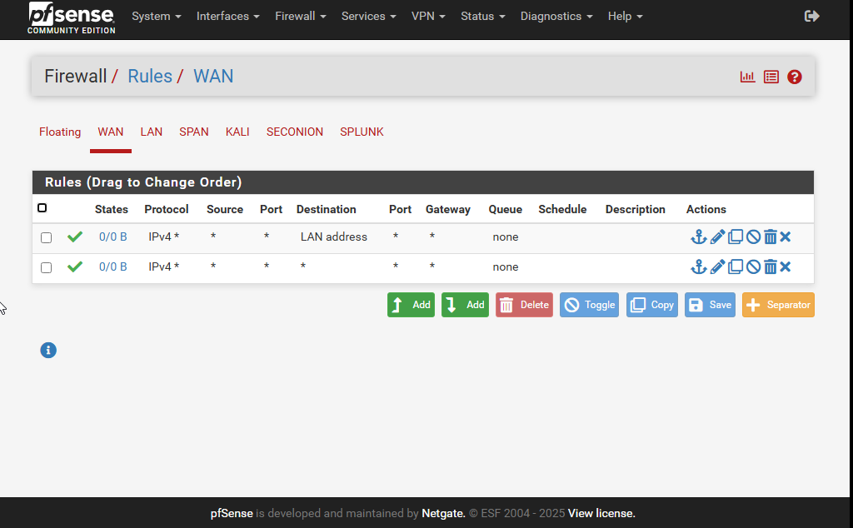*

*WAN rule*

*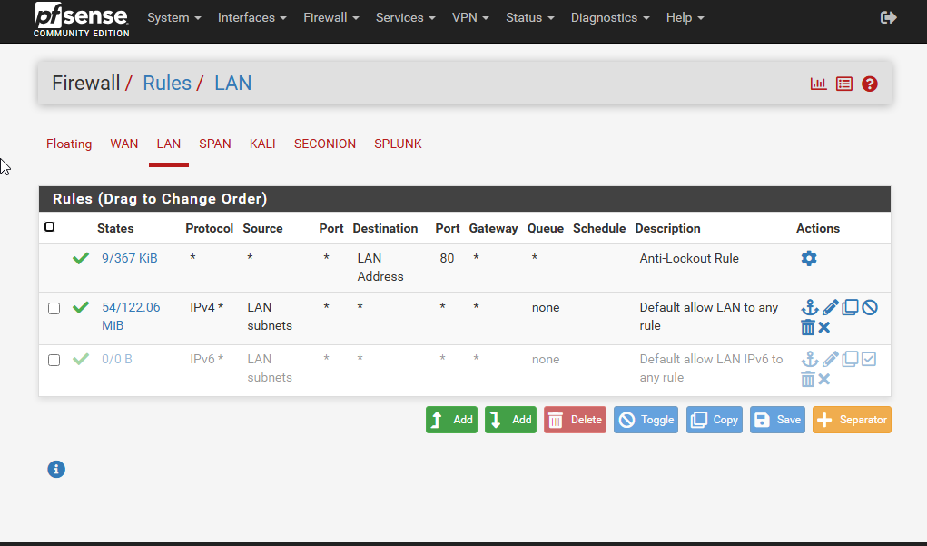*

*LAN rule*